**Weather Forecasting Application**

A weather forecasting application is a software tool designed to predict and disseminate information about future weather conditions. These applications leverage various data sources such as meteorological observations, satellite imagery, and numerical weather prediction models to generate forecasts for parameters like temperature, precipitation, wind speed, humidity, and atmospheric pressure

The primary purpose of a weather forecasting application is to provide users with timely and accurate information about upcoming weather conditions, allowing them to plan and make informed decisions accordingly. These applications are used by individuals, businesses, government agencies, and organizations across various sectors including agriculture, transportation, aviation, outdoor events, and disaster management

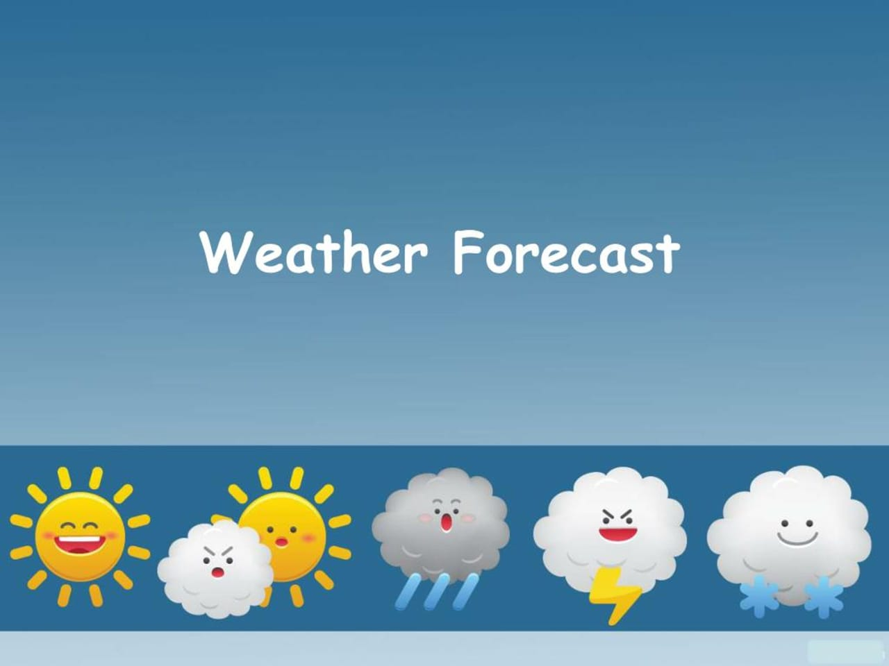

**Domain Description:-**

**1. Purpose:** The Weather Forecasting Application aims to provide accurate and timely weather predictions and analyses to users across various geographic locations. It leverages advanced meteorological models, real-time data collection, and sophisticated algorithms to generate forecasts for short-term and long-term weather conditions

**2. Functionality:**

* **Weather Prediction:** The application generates forecasts for parameters such as temperature, precipitation, wind speed, humidity, and atmospheric pressure.
* **Geographic Coverage:** It covers a wide range of geographic regions, from local neighborhoods to global scales, allowing users to access weather information relevant to their specific location.
* **Forecast Accuracy:** Emphasizing accuracy, the application utilizes state-of-the-art meteorological models and data assimilation techniques to minimize errors and improve the reliability of predictions.
* **Real-time Updates:** Users receive real-time updates on weather conditions, enabling them to stay informed about any changes that may affect their plans or activities.
* **Customization:** Users can customize their weather preferences, such as units of measurement, preferred time intervals for forecasts, and specific weather alerts.
* **Historical Data:** The application archives historical weather data, allowing users to access past weather conditions and trends for analysis and reference.
* **Visualization:** Weather forecasts and data are presented through intuitive visualizations, including maps, charts, and graphs, to enhance user comprehension and decision-making.
* **Weather Alerts:** The application issues alerts for severe weather events, such as storms, hurricanes, floods, or extreme temperatures, to help users take necessary precautions.

**3. Scope:** The Weather Forecasting Application caters to a diverse user base, including individuals, businesses, government agencies, and organizations with interests in weather-sensitive activities such as agriculture, transportation, aviation, outdoor events, and disaster management.

**4. Technologies:** The application utilizes a combination of meteorological sensors, satellite imagery, weather stations, computational models (e.g., numerical weather prediction models), data assimilation techniques, machine learning algorithms, and user interface technologies for data visualization and communication.

**5. Stakeholders:** Stakeholders involved in the development and operation of the Weather Forecasting Application include meteorologists, data scientists, software engineers, UX designers, weather data providers, government agencies (e.g., meteorological departments), private organizations (e.g., weather service providers), and end-users.

**6. Future Development:** Future developments may include enhancements in forecast resolution and accuracy, integration of more advanced predictive models, incorporation of crowd-sourced weather data, expansion of geographic coverage, and adaptation to emerging technologies such as Internet of Things (IoT) for real-time data collection.

**Historical data:-**

Historical data in a weather forecasting application refers to past weather observations and records collected over time. These data serve several important purposes within the application:

**1.Training Models**

**2.Validation and Calibration**

**3.Trend Analysis**

**4.User Reference**

**5.Model Initialization**

**ER Diagram:-**

